ON THE ROAD TO EMMAUS
I don’t know your situation as you read this. I know you are at home, probably sat in a comfy chair or at your computer. Maybe you were flicking through your emails and thought you’d just have a quick read to see if I’ve got anything useful to say. Maybe you have deliberately sat down with your Bible to think about the passages for this Sunday.
When we come together in church, we always start by calling each other to worship, reminding ourselves to tune in to God and start paying attention to him. So, whatever is going on with you right now, let me invite you to do exactly that. Turn your eyes upon Jesus and open your ears and your heart to his Holy Spirit. Expect him to meet you and speak to you right where you are.
If you haven’t already, read Luke 24:13-35.
This is the familiar account of the two disciples on the road from Jerusalem to Emmaus, walking the seven miles home on a Sunday afternoon because there was nothing left for them in Jerusalem. Jesus had been crucified and buried. All their hopes were shattered. Miserable and bewildered, they walked home, rehashing all that had happened and bemoaning together their confusion and disappointment.
A stranger drew alongside and joined their conversation. He listened as they poured out all their troubles. And then he responded: ‘How foolish you are, and how slow of heart to believe.’ That must have woken them up and jolted them out of their melancholy mood.
The stranger reminded them of their Bible – our Old Testament. More than that, he talked to them about all the prophecies of the Messiah. Do you know where the coming of Jesus is first foretold? In Genesis 3, in God’s judgement on the serpent who beguiled Eve. God says to the serpent: I will put enmity between you and the woman, and between your offspring and hers; he will crush your head and you will strike his heel (Genesis 3:15). God promised right there at the beginning that a man would be born who would defeat Satan but be wounded himself in the process. From that first assurance, the Old Testament is full of promises that Christ would come, defeating sin and death and reconciling humanity with God. Details of his birth and life and death were written centuries before by all sorts of people and it all happened just as they said.
Of course we know that it was Jesus himself who joined these two disciples on the Emmaus Road, Jesus who explained to them what was said in the Scriptures concerning himself. Wow, that must have been some sermon!
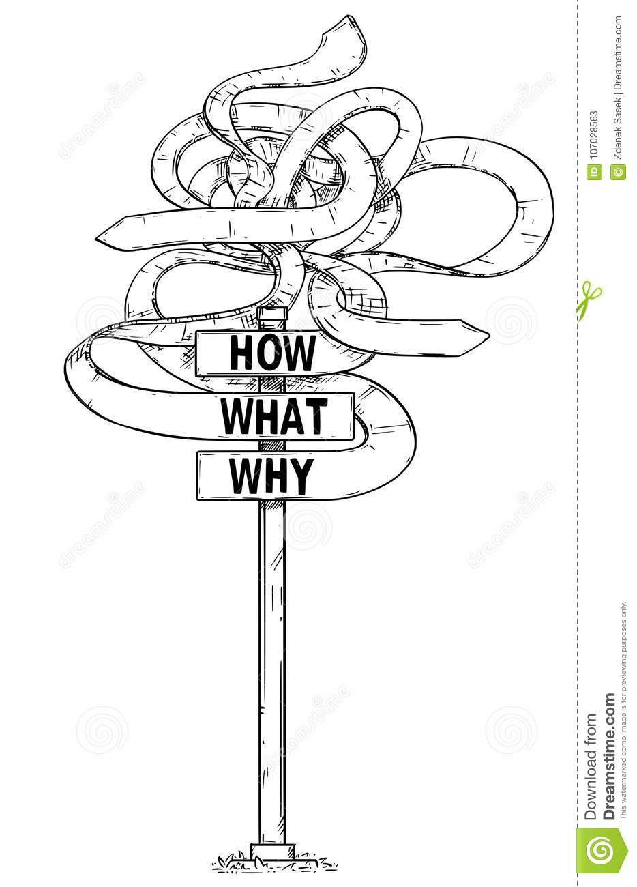
The two on the road to Emmaus were suffering from information overload. Frightened and disillusioned and grieving after Jesus’ death, they began to hear stories that he was alive. They didn’t know what to believe or how to process it all.
I am sure that sounds familiar at the moment. We are bombarded with so much information – statistics and opinions and personal stories. It leaves us bewildered and unsure who to trust. The questions those disciples had are echoing across our world in the face of this devastating pandemic. Where is God in all this? Where is Jesus? What are we supposed to think?
But into the disciples’ confusion and disillusionment walked Jesus. They made room for him. They listened to his explanation and reconnected with him. Their hearts burned within them and they saw everything differently. They gained a new perspective – God’s perspective.
When God speaks, he is not just offering us another point of view to put into the mix. God’s Word is truth and it eclipses all other opinions and explanations. Taken as a whole, the Bible gives us the only correct picture of God and of life on earth. It shows us the right way to understand all that is going on in us and around us.
Let me tell you about a woman named Holly Burkhalter. Holly Burkhalter is one of the foremost human rights advocates of the last few decades and for most of her adult life she was also a devout atheist. When she looked at the suffering in the world, she just couldn’t square it with the idea of an all-loving, all-powerful God. She worked with and campaigned for the despised and the abused and she asked the question, ‘Where is God in all this?’
Holly attended an international conference about the banning of landmines. One of the speakers was a Ugandan lady named Margaret. Margaret had been on a bus, returning home from work when it was ambushed by Ugandan rebel forces. The fighters pulled women and girls off the bus and raped them. To escape, Margaret scrambled off the road into the bush. She stepped on an antipersonnel mine and lost her leg.
To Holly, Margaret’s horrendous injury was reason enough to curse God and turn her back on him. But Holly was astounded by what Margaret said next. From a podium in front of several hundred activists around the world, Margaret thanked God for her amputation. She said she experienced Jesus' presence much more after her injury, that he had blessed her daily with love and friends and had given her good work to do in helping other land mine survivors.
This was Holly’s response, in her own words:
I was embarrassed. I was a lifelong atheist and so were most of my friends in the crowd. This woman was apparently a religious nut – who knew? But my thoughts shamed me. Margaret had something I didn't. She was powerful and gracious, and she lived a life of radiant gratitude. I didn't live a life of any gratitude, come to think of it. In addition to being embarrassed, I was envious. Somehow, Margaret helped me reconcile a lousy world with a good, loving, and powerful God. Margaret herself was evidence of God's plan to heal a ruined, suppurating world. As a Christian believer, she took literally the words of the Bible that called on her to seek justice and protect the weak. This one-legged woman strides into a world of suffering and makes it better for being there.
Because of Margaret’s testimony, Holly put her faith in Jesus and became a Christian. You can read more of her story in her book, Good God, Lousy World, and Me.
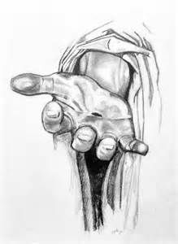
When we ask that question, ‘Where is God in all this?’ The answer is to look a little closer and we will find him. In fact, as we stop and look more carefully, it is Jesus who finds us.
He found his disciples, confused and scared, and he answered all their questions. He himself is the answer. Look at me Jesus says. Touch me, know me, experience me, understand me. Knowing Jesus is not just an intellectual exercise, it is an experiential one.
Jesus wasn’t a ghost or an apparition – he was warm flesh and solid bone. A real person who enjoyed everyday food and the companionship of ordinary people. But he is also so much more.
Understand me, Jesus said. You know the scriptures – I am there in every book. The Holy Spirit of Jesus opens their minds so that they can appreciate who he is and what his death and resurrection were all about.
Know me in the Bible, Jesus says. Read it and chew it over. Feed on me in your hearts through faith.
We don’t just have a compassionate God who joins us in our confusion and difficulty, we have a powerful God who can fill us with his strength and his clarity and lead us through and out the other side.
Jesus wants us to know his reality. It is easy to think of him as less real, less substantial than the things we see around us. In fact, he is more real than anything and anyone else. That was Margaret’s experience, that dear Ugandan lady who stepped on a landmine. That was the disciples’ experience. That became Holly Burkhalter’s experience too.
Where is God in all this? He is right here, real and fully present. Know me in the realities of everyday life, Jesus says. Know me in the uncertainty and the mess. Know me in pain and in pleasure and in the sheer joy of being alive. Know me as the One who walks beside you and the One who sits on the throne of the universe. Know me and share me.
We are all walking an unfamiliar road that is hard and challenging for so many. Jesus is right beside us. May we feel our hearts burning within us as Jesus walks and talks with us along this road, shining his hope and truth into our lives. And as we know him, experience him and understand him, then like Margaret, Holly and the disciples, let us go and share him with every person we make contact with.

